Directions: Sketch the graphs of the following functions.
$f(x)=\sqrt{x−4}+7$ $f(x)=−(x−5)^{2}+3$ $f(x)=|x−4|−1$ $f(x)=|−x+3|+6$

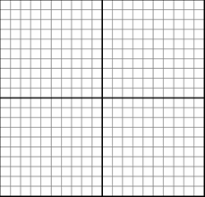

$f(x)=\frac{1}{x+6}+3$ $f(x)=\frac{1}{2}\sqrt{x+2}−8$ $f(x)=(x+1)^{2}−4$ $f(x)=(x+2)^{3}−5$

Directions: Describe (in words) the shifts and transformations of each function.

$f(x)=4|x−2|−1$$f(x)=\frac{4}{x−1}−5$

